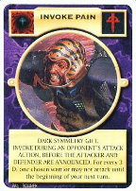
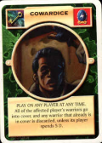
COMBAT BREAKDOWN – NEW INTERNATIONAL VERSION
Some card examples…
I - ANNOUNCE COMBAT
- Attacking player may play PAAT (Play At Any Time) cards
- Defending player may play PAAT cards
----------------------------------------------------------------------------------------------------------------------------------------------------------------------------------------------------------------------------------------
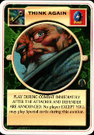
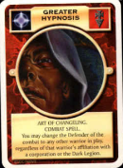
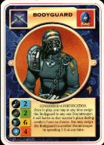
II - ANNOUNCE ATTACKER AND DEFENDER
Attacking player announces attacker and defender
(Last chance to change combatant)
1) Attacking player may play PAAT cards
2) Defending player may play PAAT cards and/or play card effects to change attacker and defender
----------------------------------------------------------------------------------------------------------------------------------------------------------------------------------------------------------------------------------------
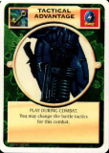
III - ANNOUNCE BATTLE TACTIC
Attacking player announces battle tactic
- Defending player may play PAAT cards and/or play card effects
to counter battle tactic
- Attacking player may play PAAT cards and/
or play card effects to counter battle tactic
----------------------------------------------------------------------------------------------------------------------------------------------------------------------------------------------------------------------------------------
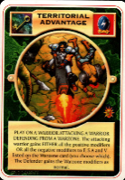
IV - ANNOUNCE WARZONE
Defending player announces if defender will defend from a Warzone, and which one.
- Attacking player may play PAAT cards and/
or play card effects to counter warzone
- Defending player may play PAAT cards and/or play card effects to counter
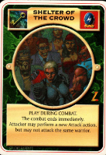
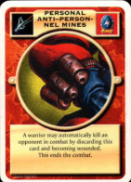
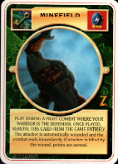
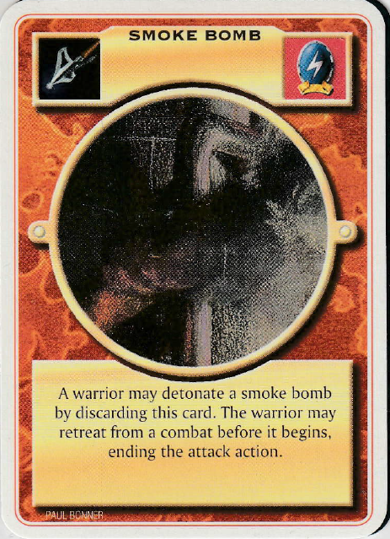
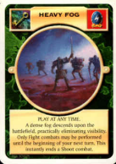
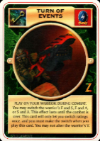
----------------------------------------------------------------------------------------------------------------------------------------------------------------------------------------------------------------------------------------
V - MODIFY COMBAT RATINGS INCL. DETERMINE EQUIPMENT - LAST CHANCE TO END COMBAT
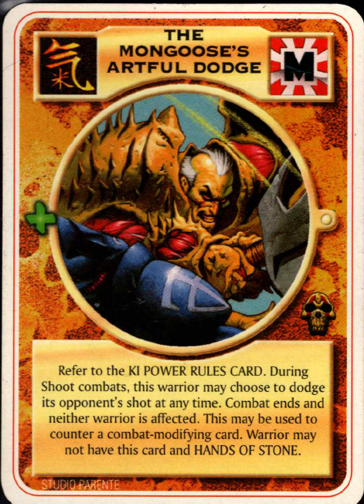
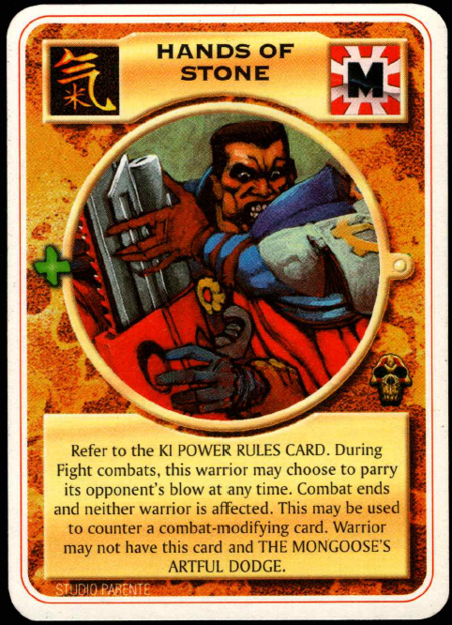
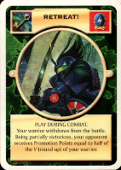
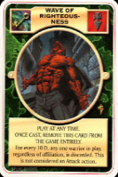
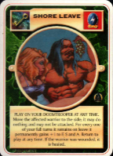
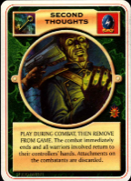
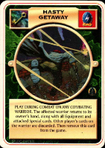
- Attacking player may play PAAT and/or play card effects to modify combat
and determine equipment/relic cards he will use or activate
(in case you lose a weapon (F/S), you can choose any other (F/S) weapon you have)
- Defending player may play PAAT cards and/or play card effects to modify combat
and determine equipment/relic cards he will use or activate
----------------------------------------------------------------------------------------------------------------------------------------------------------------------------------------------------------------------------------------
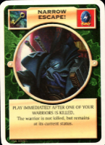
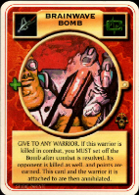
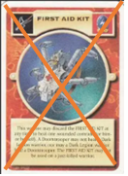
VI - RESOLVE COMBAT
1) Determine final combat standings and determine who is wounded and who is killed
2) Attacking player plays card effects to "save" wounded and/or killed warriors.
3) Defending player plays card effects to "save" wounded and/or killed warriors.

VII - CHANGE WARRIOR STATUS
- Wounded warriors are rotated, killed warriors are discarded / annihilated.
-------------------------------------------------------------------------------------------------------------------------------------------------------------------------------------------------------------------------------------

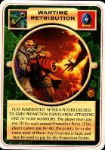
VIII - AWARD POINTS
- Attacking player is awarded any points earned.
- Defending player is awarded any points earned.

--------------------------------------------------------------------------------------------------------------------------------------------------------------------------------------------------------------------------------------
--------------------------- COMBAT IS NOW "FINISHED” -------------------------------------------

First strike
- In case of “first strike” the warrior/ player may always play (special) PAAT cards – first, even before attacking player (in Phases II-VI)
- If opponent can retaliate before step VII (CHANGE WARRIOR STATUS), he can wound or kill the warrior with “first strike” ability e.g. if he is using “narrow escape”

I - ANNOUNCE COMBAT | Invoke Pain  Cowardice
II - ANNOUNCE ATTACKER AND DEFENDER | Greater hypnosis  Bodyguard  Think again
III - ANNOUNCE BATTLE TACTIC | Tactical advantage
IV - ANNOUNCE WARZONE | Territorial advantage
V - MODIFY COMBAT RATINGS INCL. DETERMINE EQUIPMENT / RELIC USAGE | Surprise attack  PAP Mine  Turn of events  To be or not to be  Shelter of the crowd  Heavy fog  Minefield  Hasty getaway  Second thoughts  Leave shore  Wave of righteousness  Retreat
VI - RESOLVE COMBAT
VII - CHANGE WARRIOR STATUS | Narrow escape  First aid kit  Brainwave bomb
VIII - AWARD POINTS | Wartime retribution

-----------------------------------------------------------------------------------------------------------------------------------------------------------------------------------------------------------------------
DEFINITION PAAT CARDS
All PAAT cards can be played at any PAAT phase. Except:
- The card text says “has to be played in one of the steps I –VIII
- The impact of the card directly refers to one of the steps I – VII
in the cases (1) and (2) PAAT cards can only be played in the referring step
Examples:
- TACTICAL ADVANTAGE only --- Step III
- MINEFIELD (combat immediately ends…) only --- Step V
But
- WAVE OF RIGHTEOUSNESS --- any PAAT phase
- COWARDICE --- any PAAT phase

